Dartford
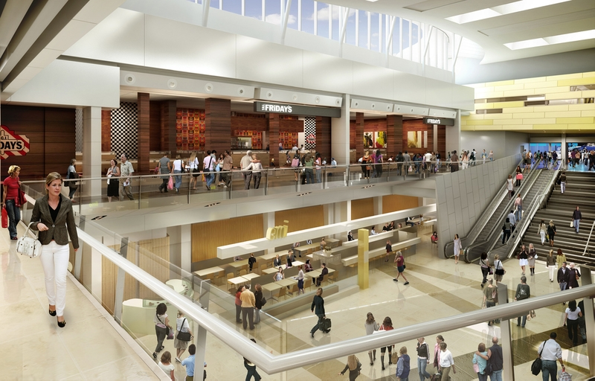
Superb shopping at Bluewater, excellent rail links to Europe and London, a rich river heritage, outdoor adventures and an AONB, all add to the appeal in this vibrant segment of Kent.

Bluewater, on Dartford's eastern edge, is billed as Europe's largest, most innovative shopping centre. Its vital statistics are impressive: 28 million visitors annually, 330 brands, 50 restaurants and bars and 13,000 free parking spaces.

Gravesend and Dartford are well connected as well: Eurostar trains from nearby Ebbsfleet International Station reach Paris in just over two hours and Brussels in one and a half hours. Domestic trains link the area with London St Pancras in a speedy 18 minutes. Dartford attracts a London Fringe Weighting.

Local Schools:- http://www.kent.gov.uk/education-and-children
Local House prices:- http://www.rightmove.co.uk/house-prices/Dartford.html

Local area information - trust locations

Medway
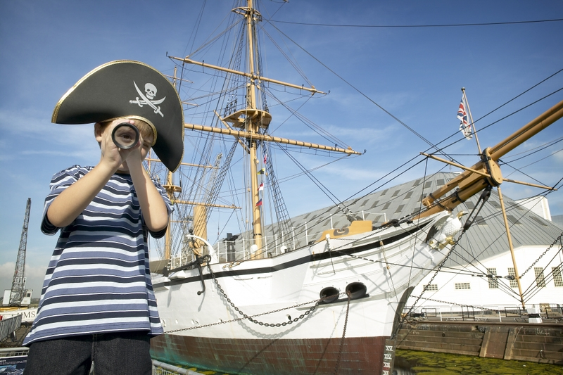
Medway is a vibrant, destination offering enlightening experiences with many stories to tell. It is a place steeped in history and rich in maritime heritage with Rochester's splendid castle and cathedral and, in Chatham, a prospective World Heritage Site.

The area is in north Kent, just 35 minutes by train from London and the same distance from the Channel ports.

If you are looking for a place to visit on a short break, you will be surprised how much there is on offer in Medway. Whether you are interested in exploring the places that Charles Dickens loved and wrote about; visiting heritage and family attractions or attending our popular festivals and events - you will find an area packed with excitement, variety and unique stories.

Local Schools:- https://www.medway.gov.uk/info/200137/schools_and_learning
Local House prices:- http://www.rightmove.co.uk/property-for-sale/Medway.html

Maidstone
Welcome to Maidstone with its fantastic shopping and parking offer at places such as Fremlin Walk and Maidstone Market.
If you love to be outside you will find some great outdoors and adventure activities to keep you entertained such as the amazing Kentish Lady River Cruises, as well as some great cycling and walking routes. Maidstone also boasts some of the best family attractions too such as Buckmore Park Karting Circuit, Iquanodon, Kent Life Heritage Farm,Headcorn Aerodrome and Teapot Island!

Or if you prefer a more relaxing break we have some excellent museums and galleries, magnificent castles such as the amazing Leeds Castle, beautiful parks and gardens such as the relaxing Mote Park, River Medway and North Downs as well as some quaint historic villages nestled in the beautiful countryside. If places to eat and drink is essential for you then Maidstone won’t disappoint.

Local Schools:- http://www.kent.gov.uk/education-and-children
Local House prices:- http://www.rightmove.co.uk/house-prices/Maidstone.html

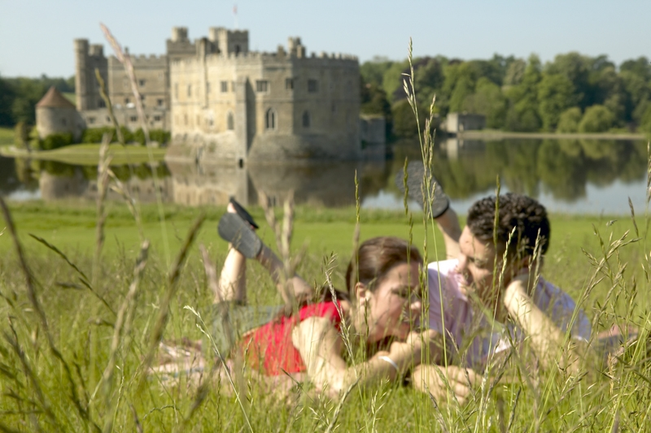
Tunbridge Wells
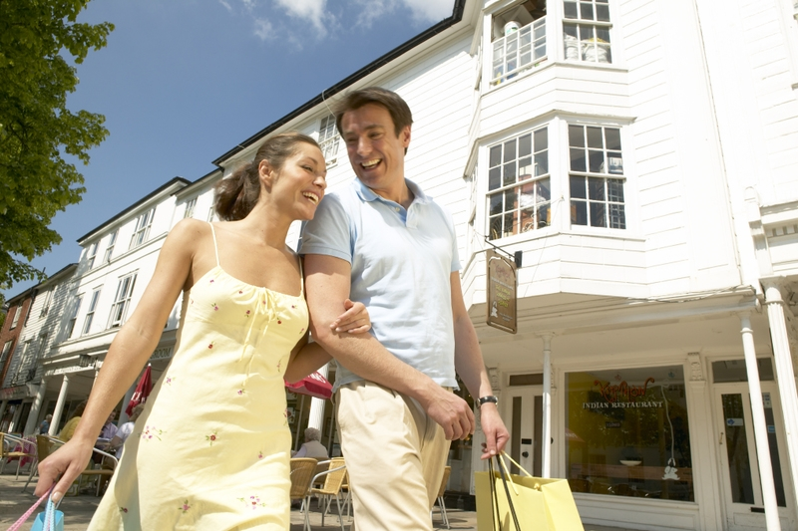
Tunbridge Wells offers Kentish town and country at its best. The historic spa town of Royal Tunbridge Wells has welcomed visitors for over 400 years. Browse among the chic independent shops of the colonnaded Pantiles and the High Street, with buzzy cafe's bars, music and one-of-a-kind shops. Dine out at one of the many restaurants in the town including the Michelin-starred Thackerays. Stay in the town’s high quality accommodation, there is something for everyone.

Local Schools:- http://www.kent.gov.uk/education-and-children
Local House prices:- http://www.rightmove.co.uk/house-prices/Tunbridge-Wells.html

Canterbury
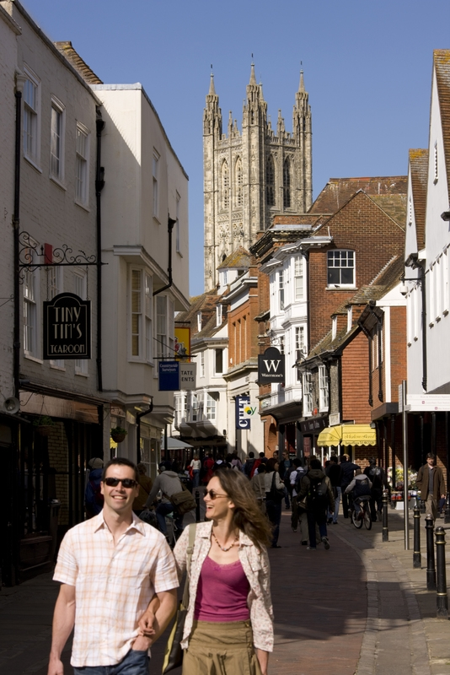
Experience Canterbury's history and heritage. See our stunning architecture and world famous buildings.

Enjoy a day out in Canterbury UK and visit the magnificent Canterbury Cathedral, have a relaxing short break or longer fun-filled family holiday at the seaside in Herne Bay or Whitstable. Canterbury tourism has the perfect blend of city, coast and countryside, ensuring that however varied your interests are you will be spoilt for choice. Come and enjoy our beautiful coastline and countryside and our breath-taking heritage and culture. After all, Canterbury is simply inspirational.

Local Schools:- http://www.kent.gov.uk/education-and-children/schools/school-places
Local House prices:- http://www.rightmove.co.uk/house-prices/Canterbury.html

This is Kent's enticing blend of ancient and modern at its very best. Here international rail links, thriving market towns and world-class chefs meet history-rich villages, idyllic countryside and superb local vineyards

Money-wise fashionistas flock to McArthur Glen’s Ashford Outlet for discount designer labels, and to Ashford's County Square. There's history here too. Ashford’s heritage trail leads down lanes lined with mediaeval, Jacobean and Georgian homes. Nearby is Godinton House - one of Kent's finest historic estates. To eat and sleep in style choose from classy cooking at the Secret Garden; country house luxury at Eastwell Manor; the sleek Ashford International Hotel; the London Beach Hotel, Spa and Country Club or two Holiday Inns.
All around Ashford lies bewitching heritage Kent. A centuries-old landscape that's also home to world-class vineyards such as Chapel Down Winery. Drop by for a tour and tutored tasting.

Local Schools:- http://www.kent.gov.uk/education-and-children
Local House prices:- http://www.rightmove.co.uk/house-prices/Ashford.html

Ashford


Thanet
Dover
The White Cliffs of Dover are iconic. Immortalised in song and film for decades, this spectacular wall of crumbly, creamy chalk stretches for 20 miles. Drink in its craggy beauty on a ferry to Dover or a high speed RIB; on a cliff-backed beach or a cliff-top trail to the South Foreland Lighthouse; the National Trust Visitor Centre and Samphire Hoe make great places to start.
The history is so vivid at Dover Castle the past feels more like the present. Overlooking the Port of Dover, this magnificent fortification is alive with vibrant furnishings, every-day artefacts and costumed actors. The audio-visual displays of the castle's Secret Wartime Tunnels evoke an underground hospital and the retreat from Dunkirk. Meanwhile, the Dover Museum provides a new twist on cross-channel ferries: a 3000 year-old, sea-going Bronze Age boat.
Local Schools:- http://www.kentadvice.co.uk/individual-schools/kent-primary-schools/item/118-dover-primary-schools.html
Local House prices:- http://www.rightmove.co.uk/house-prices/Dover.html

Deal
Don't miss Deal in Kent with its award-winning high street, mazy smugglers' lanes and independent shops. Buzzing cafes and pubs sit alongside a photogenic seafront that's home to a sweeping pier and quirky maritime clock; the Timeball Tower. Prowl the battlements and captain's quarters at Deal Castle, then visit nearby Walmer Castle - this former command post to the Duke of Wellington even features an original pair of Wellington boots. At days end sleep beside the waves at the Royal Hotel on Deal seafront. Deal, Kent is all you need.
Local Schools:- http://www.schools-search.co.uk/school-search-town.php?town=DEAL
Local House prices:- http://www.rightmove.co.uk/property-for-sale/Deal.html

Margate, Broadstairs and Ramsgate
A world-class art gallery, gourmet dining and adrenaline-fuelled water sports, plus 15 spectacular beaches and bays - a revitalised corner of Kent awaits.
Kent's northeast tip has always been cosmopolitan with its European connections, but these days there's even more creative flair in the air. Stunning sea- and sky-scapes famously drew JMW Turner to Margate, fittingly it's now home to the acclaimed Turner Contemporary gallery, which brilliantly showcases historical and contemporary works.
Artistic energy infuses an Isle where surf schools rub shoulders with ice cream parlours, chic eateries neighbour traditional chippies; and funky cafés, studios and shops pepper the streets of Margate Old Town. There's a retro feel to these harbour towns, with vintage and independent stores galore, or sit on the secluded, sands at beautiful Botany Bay
Local Schools:- http://www.schools-search.co.uk/school-search-town.php?town=MARGATE
Local House prices:- http://www.rightmove.co.uk/property-for-sale/Margate.html

Folkestone
In regenerated Folkestone quaint streets meet cutting-edge art. In the Creative Quarter 100 artistic enterprises fill the cobbled, historic heart of town, along with pastel-painted studio-galleries, quirky stores, cool bars and chic eateries. A short stroll away, the mile-long cliff-top promenade of The Leas offers sea views to France. Ride the historic Leas Lift down to the Lower Leas Coastal Park for a picnic or a BBQ, then get some sand between your toes on Folkestone's Sunny Sands beach. Restaurants abound; try Rocksalt for super-fresh fish and superb harbour views. Eurotunnel Le Shuttle brings France closer too; from Folkestone, Calais is just 35 minutes away
Local Schools:- http://www.schools-search.co.uk/school-search-town.php?town=FOLKESTONE
Local House prices:- http://www.rightmove.co.uk/property-for-sale/Folkestone.html

