**COMMITTEE MEETING**

**Meeting details**

**Committee:** Quality Committee

**Date of Meeting:** 21st July 2025

**Title of Paper:** Quarterly Mortality Review (Quarter 1 2025/26)

**Author:** Frances Lowrey, Mortality Review Manager

**Executive Director:** Andy Cruickshank, Chief Nurse

**Purpose of Paper**

**Purpose:** Approval

**Submission to Committee:** Regulatory requirement for each financial quarter

**Overview of Paper**

The Mortality Review report includes patient mortality incidents reported in Q1, 2025/26, comparing to previous quarters. The data includes natural causes and unexpected deaths, including suspected suicides.

Mortality data is reviewed monthly and presented at the Mortality Review Group for discussion. Actions are assigned to members when required.

**Issues to bring to the committees attention**

* Q1 saw a reduction in mortality rates, compared to Q4 24/25. Figure 2 shows that there has been natural cause variation from January to June 2025. The fluctuation may be indicative of retrospective reporting, as highlighted to the Board previously. Work in underway analyse mortality rates by date of death.
* Completed Structured Judgement Reviews (SJRs) in Q1 have demonstrated areas of good practice, with minimal areas for improvement highlighted.
* The Trust are exploring what appears to be higher numbers of suspected suicides in June 2025, following a decrease in April and May. The review will examine if areas such as service, demographics, a change in process (implementation of new risk forms) have contributed to this increase.
* Work regarding health inequalities and gaps in demographic recording is to continue through the Equity for All Working Group and strategic objectives.

**Governance**

**Implications/Impact:** Patient safety

**Risk recorded on:** Trust Risk Register

**Risk IDs:** 7668. **Current Rating:** 9 **Target rating:** 6

**Assurance/Oversight:** Mortality Review Group and Trust Wide Patient Safety and Mortality Review Group

1. **INTRODUCTION**

1.1 The purpose of the report is to fulfil the expectations in relation to reporting, monitoring and the Board’s oversight of mortality incidents, as set out in the National Quality Board’s ‘Learning from Deaths’ guidance (March 2017). This builds on the recommendations made by the MAZARS investigation into Southern Health (Dec 2015), the CQC report ‘Learning, Candour and Accountability publication’ (Dec 2016) and the Learning Disabilities Mortality Review (LeDeR) which is managed by NHS England. This is further reflected in our local policies and procedures to ensure we discharge our duties effectively, and as such the Committee would be familiar with the report history and purpose.

1. **HOW MORTALITY IS REVIEWED IN KMPT**

2.1 The Patient Safety Incident Reporting Framework (PSIRF) was introduced by the NHS to improve how we learn from patient safety incidents or events. We'll also learn from good practice when things go well.

2.2 The Patient Safety Incident Response Framework (PSIRF) sets out how the NHS responds to these patient safety events so we can learn from them and improve patient safety.

2.3 There are national and local PSIRF priorities that KMPT are guided by. Local priorities are regularly reviewed and can be amended dependant on our what our data tells us.

2.4 A patient safety incident decision panel takes place weekly. The purpose of the group is to review incidents (including mortality) that may require further exploration, such as a Thematic Review( TR), After Action Review (AAR) or Patient Safety Incident Investigation (PSII).

2.5 In addition to this panel and PSIRF processes, the Trust has a monthly Mortality Review Group meeting, chaired by Interim Director of Quality and Safety or appointed Deputy. In this meeting, a monthly mortality report is presented to enable discussion relating to local and national mortality data. This group is made up of various Governance leads, Heads of Nursing, Complaints, Legal, and Medical representation.

1. **ANALYSIS OF INFORMATION**

**Figure 1: Mortality reported cases**

**Figure 2: Mortality SPC**

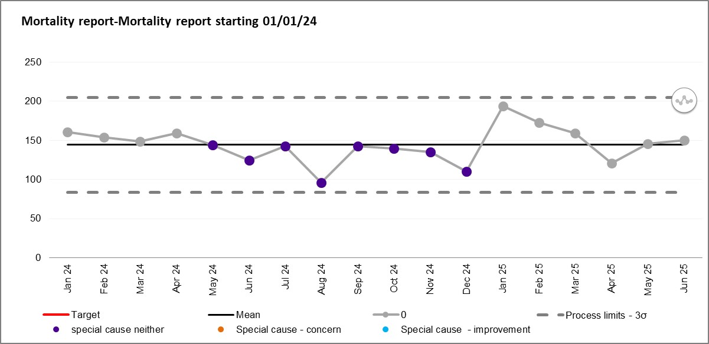

**Figure 3: Mortality moving range chart**

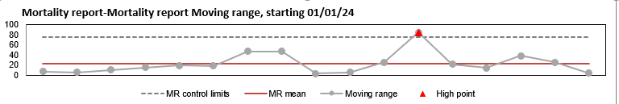

3.1 Month by month, mortality rates have continued to fluctuate, with the number of deaths reported in Q1 lower than in Q4 2024/25. The Trust continue to explore the differences in mortality rates. Retrospective reporting (as data is pulled by death reported date) can have an impact on increased numbers. The trust are also considering seasonal variation, reporting culture and reviewing data by date of death. Efforts continue to be made to link in with neighbouring organisations to compare mortality numbers.

3.2 73% of deaths reported in Q1 were patients who were over the age of 70 years, and who died of a natural cause or where the death was expected.

3.3 Unexpected deaths reported in Q1 were higher than those categorised as expected. The majority of unexpected deaths reported were sub categorised as cause of death unknown, no care and service delivery issues identified, and patients were over the age of 70 at the time of death. It is not unusual for there to be higher numbers of unexpected deaths. This is because it is not always possible for our services to obtain or confirm a cause of death. This can be for a number of reasons, including the patients place of residence, or the cause of death not being listed within shared healthcare records.

3.4 Those that are pending investigation either relate to an incident where there is an ongoing investigation or review, or where (mostly) the team investigation and learning page is yet to be completed.

3.5 There was one homicide reported in Q1. This was managed through the Immediate Management Review (IMR) process.

**Figure 4: Death/unexpected death in Q4 2024/25**

|  |  |
| --- | --- |
| **Death (Expected Death)** | **200** |
| Expected death within an Acute Trust unrelated to mental health | 77 |
| Natural causes | 22 |
| On end of life / palliative care unrelated to mental health | 101 |
| **Death (Unexpected Death)** | **211** |
| Cause of death unknown, care and service delivery issues identified | 4 |
| Cause of death unknown, no care and service delivery issues identified | 151 |
| Drug / alcohol related death | 1 |
| Natural causes | 22 |
| Pending investigation | 18 |
| Suspected or actual suicide | 14 |
| Homicide | 1 |
| **Total** | **411** |

**Figure 5: All reported mortality incidents within KMPT by gender of patients**

3.6 The Office for National Statistics (ONS) annual data, states that mortality is higher in males than in females. Trust data mirrors this finding. There are no indications that further exploration is required at this stage.

**Mortality review by ethnicity**

**Figure 6: Deaths by ethnicity**

|  |  |  |  |  |  |  |
| --- | --- | --- | --- | --- | --- | --- |
|  | 24/25 Q1 | 24/25 Q2 | 24/25 Q3 | 24/25 Q4 | 25/26 Q1 | Total |
| Asian or Asian British - Any other Asian background | 0 | 0 | 1 | 0 | 1 | 2 |
| Asian or Asian British - Bangladeshi | 0 | 0 | 1 | 0 | 0 | 1 |
| Asian or Asian British - Chinese | 0 | 1 | 0 | 0 | 1 | 1 |
| Asian or Asian British - Indian | 1 | 2 | 4 | 2 | 3 | 12 |
| Asian or Asian British - Pakistani | 0 | 0 | 0 | 2 | 0 | 2 |
| Black, African, Caribbean or Black British – African | 0 | 1 | 2 | 1 | 3 | 7 |
| Black, African, Caribbean or Black British – Caribbean | 0 | 3 | 2 | 0 | 0 | 5 |
| Black, African, Caribbean or Black British - Any other Black, African or Caribbean background | 0 | 0 | 0 | 1 | 0 | 1 |
| Mixed or Multiple groups - White and Asian | 2 | 0 | 0 | 1 | 0 | 3 |
| Mixed or Multiple groups - White and Black Caribbean | 0 | 1 | 1 | 0 | 1 | 3 |
| Mixed or Multiple groups - Any other mixed or multiple ethnic background | 0 | 0 | 1 | 2 | 2 | 5 |
| Not stated / Unknown | 82 | 62 | 77 | 116 | 88 | 425 |
| White - British | 338 | 300 | 286 | 375 | 294 | 1593 |
| White - Irish | 2 | 0 | 1 | 1 | 1 | 5 |
| Any other ethnic group | 1 | 2 | 2 | 10 | 3 | 18 |
| White - Any other White background | 2 | 10 | 7 | 15 | 14 | 48 |
| Total | 428 | 382 | 385 | 526 | 411 | 2132 |

**Figure 7: Ethnicity recording compliance- InPhase**

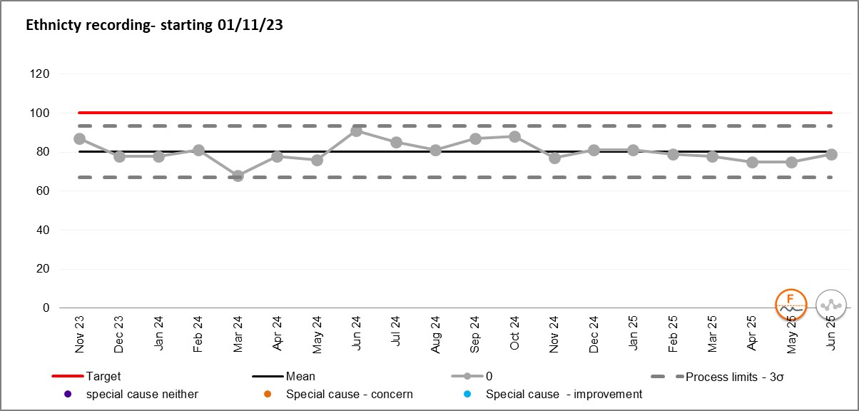

3.7 The findings regarding ethnicity are unchanged from previous mortality reports. 71% of patients are of white-British background, which is consistent with local and national data reports.

3.8 There is still little to be understood about deaths of patients of ethnic minority/other ethnic backgrounds. 3% of all deaths reported in Q1 were of patients of ethnic minority. After reviewing the data, it is not possible to identify any commonalities. One of the Trusts strategic objectives is to address health inequalities. This is a new area of focus, but of great importance. The work will explore barriers to people in Kent and Medway accessing mental health support, to ensure that the services we provide meet the needs of the local population.

3.9 There are consistent gaps in ethnicity recording (as shown in Figure 7), with 21% (88) in Q1 where the ethnicity was recorded as *ethnicity not known* or *not stated* according to the InPhase record.

3.10 Work is ongoing to link two digital systems (InPhase and RiO), to improve demographic recording. There have been delays to this project and launch date is not yet known. As previously highlighted to the Board, linking the systems will help with InPhase data quality, however will not be the primary solution to improved demographic recording. This is because ethnicity data is not shared between RiO and the national Spine when a record is synchronised. The ethnicity field however is mandatory in RiO, and therefore a selection must be picked before being able to progress with the patient record. There are options to state that ethnicity is not stated or known, and therefore 100% compliance may not always be achieved.

3.11 The Trust will work to improve this area through the Equity For All working group and strategic objective to address heath inequalities.

**4 KMPT SUSPECTED SUICIDES**

**Figure 8: Suspected suicide by month**

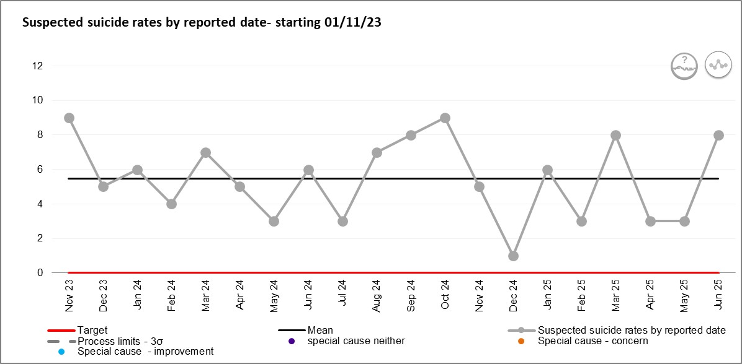

**Figure 9: Suspected suicides by age**

|  |  |  |  |  |  |  |  |  |  |  |  |  |  |  |
| --- | --- | --- | --- | --- | --- | --- | --- | --- | --- | --- | --- | --- | --- | --- |
| SUICIDES - Age Band | Jun-24 | Jul-24 | Aug-24 | Sep-24 | Oct-24 | Nov-24 | Dec-24 | Jan-25 | Feb-25 | Mar-25 | Apr-25 | May-25 | Jun-25 | Total |
| 100+ | 0 | 0 | 0 | 0 | 0 | 0 | 0 | 0 | 0 | 0 | 0 | 0 | 0 | 0 |
| 90 - 99 | 0 | 0 | 0 | 0 | 0 | 0 | 0 | 0 | 0 | 0 | 0 | 0 | 0 | 0 |
| 80 - 89 | 0 | 0 | 1 | 0 | 0 | 0 | 0 | 0 | 0 | 0 | 0 | 0 | 0 | 0 |
| 70 - 79 | 0 | 0 | 0 | 0 | 1 | 0 | 0 | 0 | 0 | 2 | 0 | 0 | 0 | 3 |
| 60 - 69 | 2 | 1 | 1 | 0 | 0 | 0 | 1 | 0 | 0 | 1 | 1 | 2 | 1 | 10 |
| 50 - 59 | 2 | 2 | 3 | 1 | 1 | 0 | 0 | 2 | 2 | 2 | 0 | 0 | 3 | 18 |
| 40 - 49 | 0 | 0 | 0 | 3 | 2 | 1 | 0 | 0 | 0 | 1 | 1 | 0 | 0 | 8 |
| 30 - 39 | 1 | 0 | 0 | 2 | 0 | 2 | 0 | 1 | 1 | 1 | 1 | 1 | 4 | 14 |
| 20 - 29 | 1 | 0 | 0 | 1 | 1 | 1 | 0 | 1 | 0 | 1 | 0 | 0 | 0 | 6 |
| 18 - 19 | 0 | 0 | 1 | 0 | 0 | 0 | 0 | 2 | 0 | 0 | 0 | 0 | 0 | 3 |
| Total | 6 | 3 | 6 | 7 | 5 | 4 | 1 | 6 | 3 | 8 | 3 | 3 | 8 | 63 |

**Figure 10: Suspected suicide by gender**

4.1 As previously highlighted to the board, the most [recent ONS stats](https://gbr01.safelinks.protection.outlook.com/?url=https%3A%2F%2Fwww.ons.gov.uk%2Fpeoplepopulationandcommunity%2Fbirthsdeathsandmarriages%2Fdeaths%2Fdatasets%2Fsuicidesbylocalauthority&data=05%7C02%7Cfrances.lowrey%40nhs.net%7C30f41c9170fc4e8d3e3208dd08ad709c%7C37c354b285b047f5b22207b48d774ee3%7C0%7C0%7C638676263236335972%7CUnknown%7CTWFpbGZsb3d8eyJFbXB0eU1hcGkiOnRydWUsIlYiOiIwLjAuMDAwMCIsIlAiOiJXaW4zMiIsIkFOIjoiTWFpbCIsIldUIjoyfQ%3D%3D%7C0%7C%7C%7C&sdata=dhYn3qaC3i32w8%2B8UCEcjSqDspHfBDBkSS6ttUGXvQQ%3D&reserved=0) for the period 2021-2023 placed the Kent (11.7) and Medway (12) rates at slightly higher than the average for England (10.7).

4.2 Kent and Medway Real Time Suicide Surveillance (RTSS) is shared with the Trust on a monthly and annual basis. Recent data showed that the number of suicides between January and May 2025 does appear to be higher than the same period in 2024, however the numbers of suspected suicides in the recent 3 months (as of July 2025) have been lower, with the gap continuing to close. RTSS data shows that, Kent and Medway wide, the highest number of suspected suicides are (as of July 2025) in Medway and Tunbridge Wells. This data includes all individuals living in Kent and Medway. Not all of whom would have been open or known to mental health services.

4.3 Digital changes to the risk forms in RiO went live across the Trust on 28th May 2025. This means that risk assessment forms used before this date were replaced with new forms, including, risk formulation, safety plan and next steps. This work aligns with the NICE guidance on self-harm and risk assessment (NG225). In preparation for going live with this change, the following was implemented:

* **Staffroom Risk Assessment Hub**. Notifications and documents added to the risk assessment hub on staffroom to keep clinicians up to date of the changes.
* **Risk screensavers** were created to promote the changes**.** Specific screensavers were designed for Risk Champions.
* **Updated Clinical Risk and Management Policy,** including a Standard Operating Procedure (SOP), summary of the process
* **Risk formulation training sessions**, facilitated by the Clinical Risk and Suicide Prevention Trainer, Approximately 89 clinicians are not trained as RiO risk Champions.
* **3 Risk conversation meetings held in May** with champions to address any question and offer support.
* **Weekly suicide risk implementation and improvement meetings.** Membership is made up of patient safety, digital, improvement and suicide prevention to monitor progress and address any concerns.

4.4 Figure 8 shows that there has been variation in the rate of suspected suicides reported each month. Natural cause variation is expected, however, there has been a noticeable increase in June 2025 with a total of 8 suspected suicides reported, following what seemed to be a decrease in April and May.

4.5 A review is currently underway to explore the increase, and determine if there is any correlation between service and team, or change in process, specifically the implementation of new risk forms from 28th May 2025. An audit on risk forms 3 months post implementation will also be completed, assess how the process is working and any areas of focus that may be required.

4.6 Figure 9 highlights that suspected suicide numbers in patients in their thirties was higher in Q1 2025/26, specifically in June (4 reported). All patients were male, in their mid to late thirties. There was no connection to a particular team. Three were under the West Kent Directorate.

4.7 The Trust is working with the Kent and Medway Suicide Prevention Programme team to promote the Baton of Hope tour which is coming to Kent and Medway on 22nd September 2025. The Baton of Hope UK tour uses an Olympic style torch to promote awareness and offer inspiration, acknowledgment and support to those who have survived suicide and/or lost someone to suicide.

4.8 The Trust continues to map workstreams against the 10 ways to improve safety toolkit. The Trust Leadership Team have been sighted on this work.

4.8 The Trust continues to work in partnership with the suicide prevention programme team, Public Health and the ICB in the prevention of suicide. Initiatives were shared at the Kent and Medway Suicide and Self-harm Prevention Network meeting in June. These include:

* Thanet District Council Suicide Prevention Strategy
* Introduction to the coastal navigators network
* Financial hardship programme (KCC) Parish Council support scheme.
* Southeastern joint suicide prevention strategy 2025-2028.

These initiatives will form useful contributions to partnership working and the overarching suicide prevention approach.

4.9 The Trust are continuing to engage in research studies into suicide, with the National Confidential Inquiry into Suicide and Safety in Mental Health (NCISH), and are about to support a new study into staff impact on patient suicide. Results once published will be shared via mortality and suicide reports.

**5 STRUCTURED JUDGEMENT REVIEW**

5.1 **17** Structured Judgement Reviews were completed in Q1 2025/26.

**Figure 12: ratings of care**

|  |  |
| --- | --- |
| Allocation and initial assessment or review (entry into services) | 1. **in total** 2. Potential Patient Safety Event: 0% 3. A Learning Opportunity: 8% 4. Expected Practice/ Process: 23% 5. Good care: 54% 6. Exemplary Practice/ Process: 15% |
| Ongoing care | **17 in total**   1. Potential Patient Safety Event: 0% 2. A Learning Opportunity: 6% 3. Expected Practice/ Process: 29% 4. Good care: 59% 5. Exemplary Practice/ Process: 6% |
| Psychiatric inpatient care | **2 in total**   1. Potential Patient Safety Event: 0% 2. A Learning Opportunity: 0% 3. Expected Practice/ Process: 0% 4. Good care: 50% 5. Exemplary Practice/ Process: 50% |
| Discharge | **6 in total**   1. Potential Patient Safety Event: 0% 2. A Learning Opportunity: 17% 3. Expected Practice/ Process: 17% 4. Good care: 67% 5. Exemplary Practice/ Process: 0% |
| Overall care | **17 in total**   1. Potential Patient Safety Event: 0% 2. A Learning Opportunity: 6% 3. Expected Practice/ Process: 29% 4. Good care: 53% 5. Exemplary Practice/ Process: 12% |

5.2 Overall care was rated good and above in 65%, of the cases reviewed. This compared to 58% in the previous quarter. Learning (including learning opportunities), has been shared across the Directorates.

5.3 1 SJR followed the escalation process (2nd SJR and decision panel discussion), due to opportunities for learning identified. The PSIRF local and national priorities were not met in this case, and learning shared with Directorates.

5.4 SJR learning has been grouped in the following areas:

|  |  |  |  |  |  |  |
| --- | --- | --- | --- | --- | --- | --- |
| **Risk assessment** | **Medication** | **Treatment and management plan** |  | **Physical healthcare** | **Communication** | **Other areas** |

5.5 Areas of good practice were identified in most SJRs, with minimal areas of learning. Most of the good care was within the treatment and management plan areas, similar to previous reports. Each category includes sub-categories to describe the area of care. The top three areas of good care and areas for learning are listed below.

**Figure 13- Areas of good care**

**Figure 14- Areas for improvement**

5.6 Other areas of good practice include, comprehensive assessment with the patient, sensitive and holistic approach to care, to build a therapeutic relationship with the patient, and extra support provided to family and carer.

5.7 Other areas for improvement include recognition of eating disorder and treatment in line with NICE guidelines and inconsistent records in healthcare records.

5.8 Physical health learning was shared with the physical health team. There were some noticeable themes in terms of documentation of physical health checks and communication with the GP. Assurance has been provided that these areas are being picked up in the physical health improvement work.

5.9 There have been two SJRs where the recommendation has been to share good practice with the assessing clinician. This is a positive outcome that has been shared with the governances team (West Kent).

**6 THE MEDICAL EXAMINER**

6.1 The Trust have established a process for referring deaths, that meet the criteria, to the Medical Examiner.

6.2 In Q1, the Medical Examiner SOP was agreed and ratified at Trust-Wide Patient Safety and Mortality Review Group, guidance on the process has also been added to Resilience Direct for on call managers. Guidance will also be added to the doctor on call pack.

6.3 In Q1, Medical Examiner offices confirmed they are willing to work with the Trust in sharing Medical Examiner summaries, when information is required to aid decision making. This includes where a cause of death might be required, or where learning has been identified.