JOB DESCRIPTION: HST OLD Age Psychiatry

JOB TITLE: HST Old Age Psychiatry

CLINICAL SUPERVISOR: Dr M. Dalvi. FRCPsych

DIRECTORATE: Old Age Psychiatry

REPORTS TO: Main speciality commitment of trainer(s):

Dr M. Dalvi for Old Age Psychiatry

Sub-Speciality commitment of trainer(s):

Dr M. Dalvi for Liaison Psychiatry

LOCATION(S): Community Base: Folkestone Health Centre 15-25 Dover Road, Folkestone CT20 1JY.

HOURS OF WORK: Monday – Friday (see timetable)

ON CALL RESPONSIBILITY: Yes

DISCLOSURE REQUIRED: Yes

Trainer: Dr Dalvi is a Fellow of the Royal College of Psychiatrists and is an educational, clinical supervisor and undergraduate trainer. In addition to a CCT in old age and general adult psychiatry, he has a liaison subspecialty endorsement on his CCT and can provide supervision and training on interactions of physical health with old age psychiatric presentations. He is a reviewer for the BMJ case report journal, foundation trainee lead in East Kent and is involved in service development for the older people’s service line. He has stage three year 4 students from King’s College London and is Honorary Senior Lecturer in Kings College London. He works within the Shepway CMHSOP to provide a comprehensive old age psychiatry service in Folkestone alongside his other consultant colleague who covers the Hythe and New Romney area. The post also has a CT1trainee. This is a fantastic job which will give the core trainee a unique opportunity to attend the weekly East Kent psychiatry neuroradiology MDM giving them a chance to develop skills in MRI, PET scan interpretation, understand basics of cognitive neuroscience, young onset dementias and opportunity to teach medical students.

Unique Specialist experience available in the placement:

1) Multidisciplinary enhanced memory clinic experience including assessment of young onset and unusual dementias, (Posterior cortical atrophy, Cognitive-motor phenotypes of young onset dementias, CADASIL related vascular dementia, transient global amnesias, primary progressive aphasias).
2) Dedicated Neuroradiology & Nuclear Medicine experience at weekly MDT.
3) Training in Section 49 report writing, Testamentary Capacity assessments and complex capacity assessment.
4) According to needs neurology/geriatric medical/stroke/falls clinic experience will be made available.
5) CT1 supervision, medical student teaching for 3rd year Kings College medical students.
6) Interpreting CT, MRI scans and specialist bloods in dementias.
7) Genetics of familiar dementias

Description of the Service:
The community mental health framework for adults and older adults sets out a new approach to providing needs-based integrated support, care and treatment in the community for adults and older adults with severe mental illness (SMI) whatever their level of need. This transformation has commenced and hence Shepway CMHSOP will no longer exist in its current form and will be a part of mental health together plus. The enhanced memory assessment service will be a standalone service and the higher specialist trainee will be a part of mental Health together plus which will have a focus on needs-based care and coproduction. The triage process, dialogue plus and trusted assessment are key to this new service and the service is based on the following principles.

a) Person-centred and trauma informed care: Focused on the strengths and needs of the individual.

b) Choice, empowerment and advocacy: People and their families/carers are actively involved in decisions about their care and treatment.

c) Access: All individuals, including those from diverse population groups, have equal access to mental health assessment, support, care and treatment.

d) Support and care across the lifespan: Care is age, and developmentally appropriate to meet changing needs throughout a person’s life.

e) This model cuts down on unnecessary repeat assessment and referrals, take
into account workforce needs including specialist and generalist roles as part of a core community mental health transformation team and ensure that it is aligned to the Ageing Well agenda and based on a matrix for low, medium and high needs.

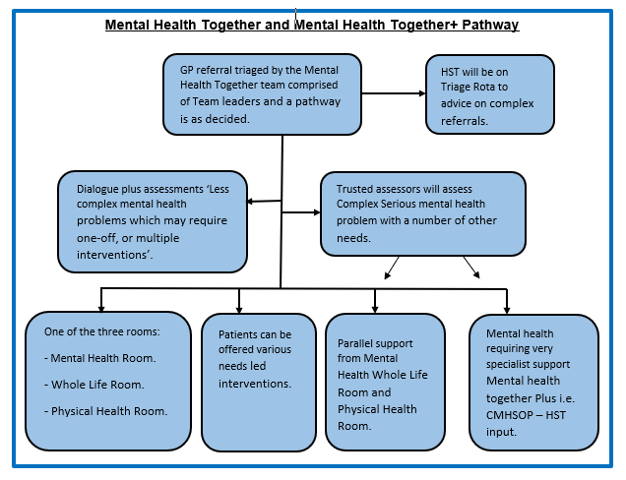
Defined Care Pathways

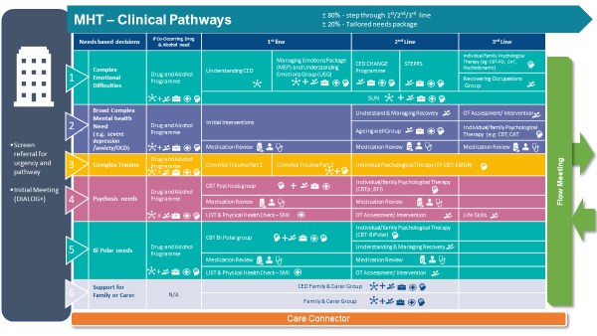

Base: The trainee will have a dedicated shared office space at Folkestone Health Centre which is also the base for the teams with dedicated administrative support. Clinics are held in Folkestone Health Centre. There can be a weekly EMIS clinic in Broadmeadow which is a 5-minute drive from Folkestone Health Centre.
Support Staff
- Medical Consultant -Folkestone
- Consultant -Hythe and New Romney
1.0 CT1 Core Trainee.
1.0 Clinical Psychologist, 1.0 Assistant Psychologist
1.0 Operational Manager for Standalone memory service,
1.0 Team Leader
3.0 Band 6 Community Psychiatric Nurses
1.0 Band 5 Community Psychiatric Nurse
0.8 Band 5 Community Psychiatric Nurse
2.0 Band 4 Support Worker
1.0 Band 7 Occupational Therapist
1.0 Band 6 Occupational Therapist (on maternity leave)
0.4 Band 6 Occupational Therapist
1.0 Admiral Nurse
0.5 Admin support
1.0 mental health well-being practitioner.

Details of placement and timetable

In the Shepway area, two consultants: Dr Dalvi and Dr Elias provide a comprehensive old age psychiatry service, including multidisciplinary assessments, outpatient assessments, community visits, weekly input in the enhanced memory assessment service.

The role of the trainee: The HST will work with the mental health together plus team for older people covering the picturesque catchment area of Folkestone. The trainee will also have input in the Enhanced memory assessment clinic and the trainee will take part in joint assessments (with CPNs, SHOs, OTs, AMHP, and psychologists) and lone assessment and treatment in some patients’ homes, care homes and will assess and manage outpatient clinic caseload, including record keeping and GP letters.

The trainee will assist in clinical assessments and if necessary ongoing management of complex community referrals. They will also attend a weekly MDT with the community team on Tuesdays, picking up complex referrals directly from team members and carrying out a clinical assessment or providing senior medical advice where necessary. The trainee will participate in the dedicated neuroradiology session with Dr Bertoni Consultant Neuroradiologist and Dr Ellul Consultant Nuclear Physician once a week. This will be a clinical session to discuss complex patients with unusual presentations but will also act as an educational session so that the trainee is able to read and interpret findings on CT, MRI scans for common neurodegenerative illnesses. In addition to this the trainee will also benefit from discussions with within Nuclear Medicine to understand SPECT, PET scans. The HST will have a weekly one-hour supervision session with Dr Dalvi.
Objectives of placement
• To develop higher level objectives as an expert and also as a teacher.
• To further develop skills in complex assessment, diagnosis and management
of functional and organic psychiatric conditions in older persons.
• To develop skills in extended cognitive examination, frontal lobe testing and interpreting Neuropsychology reports.
• To develop knowledge of the common and rare dementias including
aetiology, assessment, investigation, biological treatments, psychosocial interventions and risk assessment and management.
• To undertake complex mental capacity assessments like fluctuating capacity, testamentary capacity and improve understanding of the Mental Capacity Act and DOLS.
•To develop skills in preparing Section 49 reports for the Court of Protection, Tribunal reports for CTO’s.
•To develop skills in MRI, PET, SPECT scan interpretation by attending neuroimaging MDT.
. To develop skills in graduate assessments eg schizophrenia with cognitive deficits , ADHD, Chronic fatigue syndrome who present with cognitive changes

Educational Objectives for HST

• To develop skills in specialist risk assessments e.g. depression in dementia.
• To develop pharmacological skills in prescribing choline-esterase inhibitors in multimorbid patients and use of Lithium in the elderly and its drug, disease interactions.
• To gain experience in managing acute psychiatric emergencies.
• To develop and enhance skills in the use of the Mental Health Act.
• To develop skills in interpreting scans and blood tests.
•To develop experience in working with an MDT team and in time management.

Education and Training:
Individual supervision will be provided by Dr Dalvi for one hour every week
• Experience in the assessment and clinical management of psychiatric
emergencies are provided by on-call commitments.
• HSTs are encouraged to contribute to the teaching programme by chairing trainee journal club and topic presentations and discussions thereafter.
• HSTs are also encouraged to contribute to the induction and assist with the training and development of Core trainees, foundation trainees.
• Other teaching opportunities include teaching Stage III year IV Kings College students attached to Dr Dalvi’s firm.
• HSTs are required to complete at least one audit in their area of practice
and are encouraged to supervise trainees with audit.
• Study Leave is available within HEKSS Guidelines.

Research opportunities: Are available under the supervision of the Trust’s
medical lead for research and development. Previous trainees have had the
opportunity to publish their work in peer reviewed journals and present at
national conferences. Trainees are encouraged to undertake a quality improvement project during the placement.

Emergencies: The junior doctor accepts that he or she will also perform duties in occasional emergencies and unforeseen circumstances at the request of the appropriate consultant in consultation, where practicable, with his colleagues, both senior and junior. Additional commitments are exceptions and juniors should not be required to undertake work of this kind for prolonged periods on a regular basis. The job description includes cover of normal annual and study leave of colleagues for whom the practitioner is expected to deputise during the normal run of his or her duties.

The following table provides an indication the HST syllabus areas which can be met during a specific placement.

Domain 1: Knowledge, skills and performance | Outpatient clinics and DVs  On call assessments including review of inpatients:  - Capacity assessments  - Mental Health Act assessments.  - diverse patients to include:  - Presenting or main complaint.  - History of present illness.  - Past medical and psychiatric history.  - Systemic review.  - Family history.  - Socio-cultural history.  - Developmental history.  - Clinical history.  - Patient examination, including mental state examination and physical examination. | This will be reviewed in supervision and assessed by  WPBA including CBD, ACE, min-ACE, Neuroimaging MDT.
Domain 1: Knowledge, skills and performance | ILO2: Demonstrate the ability to construct formulations of patients’ problems that include appropriate differential diagnoses. | Outpatient clinics and DVs.  On call assessments including review of inpatients.  Mental Health Act assessments.  Reviewed in supervision and assessed by  WPBA including ACE, CBD.
Domain 1: Knowledge, skills and performance | ILO3: Demonstrate the ability to recommend relevant investigation and treatment in the context of the clinical management plan. This will include the ability to develop and document an investigation plan including appropriate medical, laboratory, radiological and psychological investigations and then to construct a  comprehensive treatment plan addressing biological, psychological and socio-cultural domains. | EMAS clinic, Outpatient clinics/DVs, Neuroimaging MDT, on call assessments including review of inpatients, Mental Health Act assessments.  Reviewed in supervision and assessed by  WPBA including, ACE, CBD.
Domain 1: Knowledge, skills and performance | ILO4: Based on a comprehensive psychiatric assessment, demonstrate the ability to comprehensively assess and document patient’s potential for self-harm or harm to others. This would include an assessment of risk, knowledge of involuntary treatment standards and procedures, the ability to intervene effectively to minimise risk and the ability to implement prevention methods against self-harm and harm to others. This will be displayed whenever appropriate, including in emergencies:  - Psychiatric emergencies for all specialties.  - Mental health legislation.  - Broader legal framework. | Outpatient clinics/DVs.  On call assessments including review of inpatients.  Mental Health Act assessments.  Reviewed in supervision and assessed by  WPBA including, ACE, mini-ACE, CBD.  Discussed at team meetings, academic meetings and Balint Group.
Domain 1: Knowledge, skills and performance | ILO5: Based on the full psychiatric assessment, demonstrate the ability to conduct therapeutic interviews; that is to collect and use clinically relevant material. The doctor will also demonstrate the ability to conduct a range of | Outpatient clinics.  On call assessments including review of inpatients  Mental Health Act assessments.  Reviewed in supervision and assessed by  WPBA including, ACE, mini-ACE, CBD.

 | individual, group and family therapies using standard accepted models and to integrate these psychotherapies into everyday treatment, including biological and socio-cultural interventions:  - Psychological therapies. | Interaction with the team psychologist at team meeting and for ad hoc discussions.  Observing senior clinician interviews in clinics.  Psychotherapy experience as arranged with the Psychotherapy tutor, including Balint Group.
 | ILO7: Develop the ability to carry out specialist assessment and treatment of patients with chronic and severe mental disorders and to demonstrate effective management of these disease states:  - Management of severe and enduring mental illness. | Outpatient clinics.  On call assessments including review of inpatients.  Mental Health Act assessments.  Reviewed in supervision and assessed by  WPBA including ACE, mini-ACE ,CBD.
 | ILO8: To develop an understanding of research methodology and critical appraisal of the research literature:  - Research techniques.  - Evaluation and critical appraisal of research. | Opportunity to engage in weekly journal club.  Attend Calman days.  Research opportunities available through supervisor or research department.  Attend courses.
 | ILO9: To develop the habits of  lifelong learning. | Register for NHS Athens, College podcasts, Dean’s grand round.  Make use of Library services (in person or online).  Read journals, attend academic programme and use CPD appropriately (e.g. attend conferences).
Domain 2: Safety and Quality | ILO10: Develop the ability to conduct and complete audit in clinical practice:  - Audit. | Opportunity to complete an audit facilitated by supervisor.
Domain 2: Safety and Quality | ILO11: To develop an understanding of the implementation of clinical governance:  - Organisational framework for clinical governance and the benefits that patients may expect. | Attend monthly governance meetings, LFG meetings.
Domain 3: Communication, partnership and teamwork | ILO13: Use effective communication with patients, relatives and colleagues. This includes the ability to conduct interviews in a manner that facilitates information gathering and the formation of therapeutic alliances. | Outpatient clinics.  On call assessments including review of inpatients.  Mental Health Act assessments.  Supervisor observed assessments.  Reviewed in supervision.
Domain 3: Communication, partnership and teamwork | ILO14: Demonstrate the ability to work effectively with colleagues, including team working. | Reviewed in supervision and through Multi Source Feedback.
Domain 3: Communication, partnership and teamwork | ILO15: Develop appropriate  leadership skills. | To attend Leadership courses.  Reviewed in supervision.
 | ILO16: Demonstrate the knowledge, skills and behaviours to manage time and problems effectively:  - Communication with colleagues. | Agree schedule with supervisor at start of placement.  Maintain a diary.  Prioritise workload.  Report working in excess of hours through exit reporting.  Reviewed in supervision.
 | ILO17: To develop the ability to teach, assess and appraise:  - Assessment.  - Appraisal. | Opportunities to teach Stage III, Year IV medical students, junior trainees and multi-disciplinary teaching within team.  Participation at the weekly academic meetings.  Assessed through Assessment of Teaching  WPBA.
Domain 4:  Maintaining trust | ILO19: To ensure that the doctor acts in a professional manner at all times:  - Doctor patient relationship.  - Confidentiality.  - Risk management.  - Recognise own limitations. | All clinical activities.  Reviewed in supervision.  Assessment through multi-source feedback and supervision.

