Annual Report
6th June 2022 - 31st March 2023

Circulation: | Sandra Goatley  Chief People Officer
Prepared by:
Jacquie Pamphilon
Guardians
Jacquie Pamphilon
Rebecca Crosby
The Guardian Service Ltd.

 | 21 June 2023

Contents
1. Executive summary 5
2. Purpose of the paper 5
3. Background to Freedom to Speak Up 5
4. The Guardian Service 5
5. Access and Independence 6
6. Categorisation of Calls and Agreed Escalation Timescale 6
7. Number of concerns raised 7
8. Confidentiality 7
9. Themes 7
10. Trends in Cases 8
11. Assessment of Cases 8
12. Statistical Graphs 8
13. Why do staff use The Guardian Service? 10
14. Detriment 10
15. Action taken to improve the Freedom to Speak Up Culture 10
16. Learning and Improvements 12
17. Comments & Recommendations 12
18. Staff Feedback 13

Executive summary
This report is the annual report from the Guardian Service Limited (GSL) prepared for Kent and Medway NHS and Social Care Partnership Trust (KMPT). As the GSL did not start working in partnership with KMPT until June 2022, the report does not cover a full financial year.
- 81 concerns were raised, the three main themes were System and Process (27 concerns), Management (15 concerns) and Worker Safety (13 concerns).
- Administrative and Clinical were the highest staff group raising concerns followed by Nursing and Midwifery
- 33.33% of staff raising concerns wanted to keep it confidential. This means that out of the 81 concerns raised, 27 staff found they were able to resolve their concern by talking things through with the Guardian. These concerns were not escalated and remained informal.
- There were no reported incidents of staff members feeling they had suffered a detriment because of speaking up.
- Regular monthly meetings are held with the Chief People Officer. The Guardian service submit a monthly report in preparation for these meetings and themes can then be discussed, and areas of concern highlighted.
- The Trust have recognised that there could be areas for development when concerns are raised and are keen to learn from outcomes where improvements have been made.
Recommendations
- Full recommendations are in the body of this report.
- There are recommendations carried forward from the six-month report with responses from the Trust of actions implemented.

Purpose of the paper
The purpose of this paper is to give insight to the progress and development of the service and a summary of themes arising from the cases received by the FTSU Guardians.
This report provides an overview from 6th June 2022 to 31 March 2023. The report follows the guidance from the National Guardian Office (NGO) on the content FTSU Guardians should include when reporting to their Board which include: Assessment of cases, Action taken to improve speaking-up culture, Recommendations.

Background to Freedom to Speak Up

Following the Francis Inquiry 2013 and 2015, the NHS launched ‘Freedom to Speak Up’ (FTSU). The aim of this initiative was to foster an open and responsive environment and culture throughout the NHS enabling staff to feel confident to speak up when things go or may go wrong; a key element to ensure a safe and effective working environment.

The Guardian Service

The Guardian Service Limited (GSL) is an independent and confidential staff liaison service. It was established in 2013 by the National NHS Patient Champion in response to The Francis Report. The Guardian Service provides staff with an independent, confidential 24/7 service to raise concerns, worries or risks in their workplace. It covers patient care and safety, whistleblowing, bullying, harassment, and work grievances. We work closely with the National Guardian Office (NGO) and attend the FTSU workshops, regional network meetings and FTSU conferences. The Guardian Service is advertised throughout the Trust as an independent organisation. This encourages staff to speak up freely and without fear of reprisal. Freedom to Speak Up is part of the well led agenda of the CQC inspection regime. The Guardian Service supports the Trust’s Board to promote and comply with the NGO national reporting requirements.

The Guardian Service Ltd (GSL) was implemented in KMPT on 6th June 2022. .

Communication and marketing have been achieved by meeting with senior staff members, joining team meetings, site visits, the Intranet and the distribution of flyers and posters across the organisation. All new staff will become aware of the Guardian Service when undertaking the organisational induction programme.

Access and Independence

Being available and responsive to staff are key factors in the operation of the service. Many staff members, when speaking to a Guardian, have emphasised that a deciding factor in their decision to speak up and contacting GSL was that the Guardians are not NHS employees and are external to the Trust.

Categorisation of Calls and Agreed Escalation Timescale

The following timescales have been agreed and form part of the Service Level Agreement.

Call Type | Description | Agreed Escalation Timescales
Red | Includes patient and staff safety, safeguarding, danger to an individual including self-harm. | Response required within 12 hours
Amber | Includes bullying, harassment, and staff safety. | Response required within 48 hours
Green | General grievances e.g. a change in work conditions. | Response required within 72 hours
White | No discernible risk to organisation. | No organisational response required

Open cases are continually monitored, and regular contact is maintained by the Guardian with members of staff who have raised a concern to establish where ongoing support continues to be required. This can be via follow up phone calls and/or face to face meetings with staff who are in a situation where they feel they cannot escalate an issue for fear of reprisal. Guardians will also maintain contact until the situation is resolved or the staff member is satisfied that no further action is required. Where there is a particular complex case, setbacks, or avoidable delays in the progress of cases that have been escalated, these would be raised with the organisational lead for the Guardian Service at regular monthly meetings.

Escalated cases are cases which are referred to an appropriate manager, at the request of the employee, to ensure that appropriate action can be taken. As not all employees want their manager to know they have contacted the GSL, they either progress the matter themselves or take no further action. There are circumstances where cases are escalated at a later date by the Guardian. A staff member may take time to consider options and decide a course of action that is right for them. A Guardian will keep a case open and continue to support staff in such cases. In a few situations contact with the Guardian is not maintained by the staff member.

Number of concerns raised
There have been 81 concerns raised from 6th June 2022 to 31st March 2023
The graph below details the number of cases open and closed on a cumulative basis

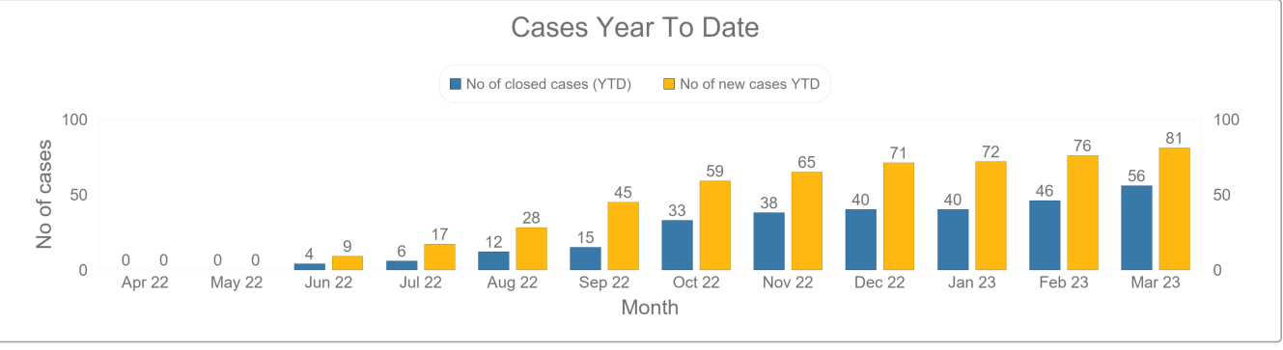

Confidentiality

Confidentiality | No. of concerns | Percentage
Keep it confidential within Guardian Service remit | 27 | 33.33%
Permission to escalate with names | 35 | 43.21%
Permission to escalate anonymously | 19 | 23.46%
Total | 81 100%

It is encouraging to note that 43.21% of staff members raising concerns were willing to escalate with their names. Although keep it confidential had an 11% rise since the first six-month report, this could be that staff members were able to take things forward after speaking with the Guardian. Sometimes a conversation enables staff members to gain clarity to find a resolution themselves.

Themes
Concerns raised are broken down into the following categories

Theme | Total
A Patient and Service User Safety / Quality | 8
B Management Issue | 15
C System Process | 27
D Bullying and Harassment | 6
E Discrimination / Inequality | 5
F Behavioural / Relationship | 6
G Other - COVID | 1
H Worker Safety | 13
Grand Total | 81

Trends in Cases
As this is the first annual report from The Guardian Service since going live within KMPT, there is no comparable data from previous years.

Assessment of Cases
Twenty-seven concerns were raised in the category of System and Process. Themes included staff members feeling that a process had not been followed when they had raised a concern internally and were not given any feedback. Staff members felt that they had not had any closure and questioned the point of raising a concern. Some staff members felt they had not been informed adequately about the process for redeployment, or temporary reduction in hours. There had been some concerns raised about pay related issues. There were concerns about data giving misleading and inaccurate results. Staff members felt this had adversely affected the provision of the service. Staff members have reported data breaches leading to sensitive information being inappropriately shared.
There where fifteen FTSU cases categorised as Management Issues. Matters raised in this theme relate to staff perceptions of managerial practice, communication, or behaviour. Concerns have included managers breaking confidentiality, incivility, and lack of communication. Staff members felt sometimes they were working with no clear direction. Staff members have conveyed to the Guardian feelings of not being listened too and not valued.
In the category of Worker Safety there were thirteen concerns raised. Themes included pressures on staff due to staff shortages, concerns of violent patients being held too long on a ward. Also staff felt moving to a specific office could be damaging to health. All worker safety concerns raised were addressed and resolutions offered to improve the situations.

Statistical Graphs
Concerns raised by Directorate

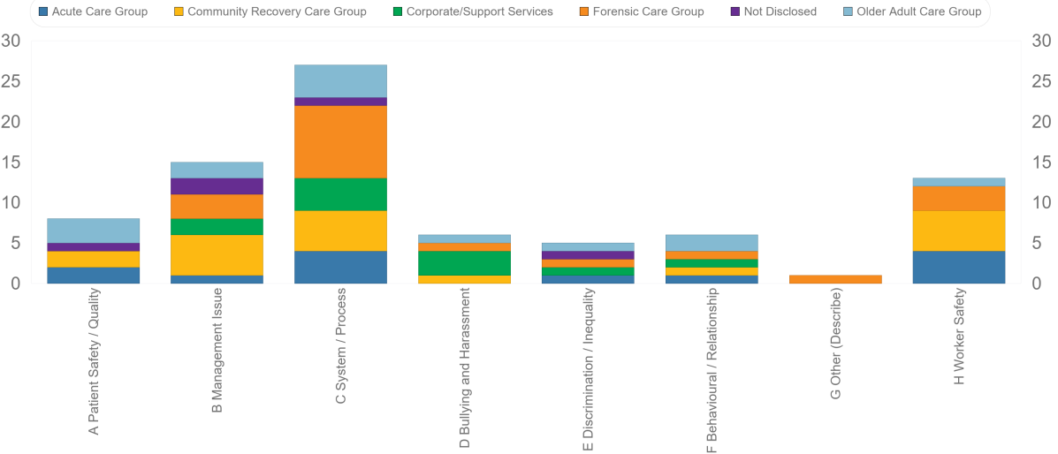

Concerns raised by Location

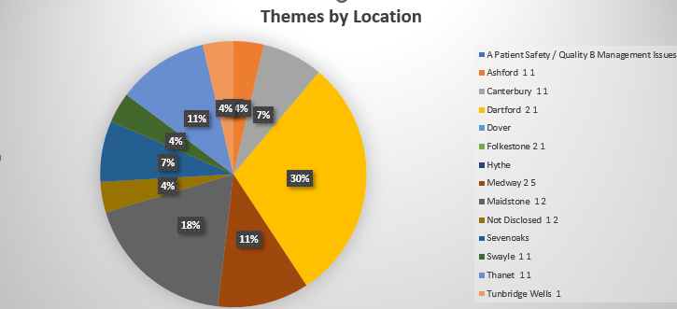

Staff Percentages by Location
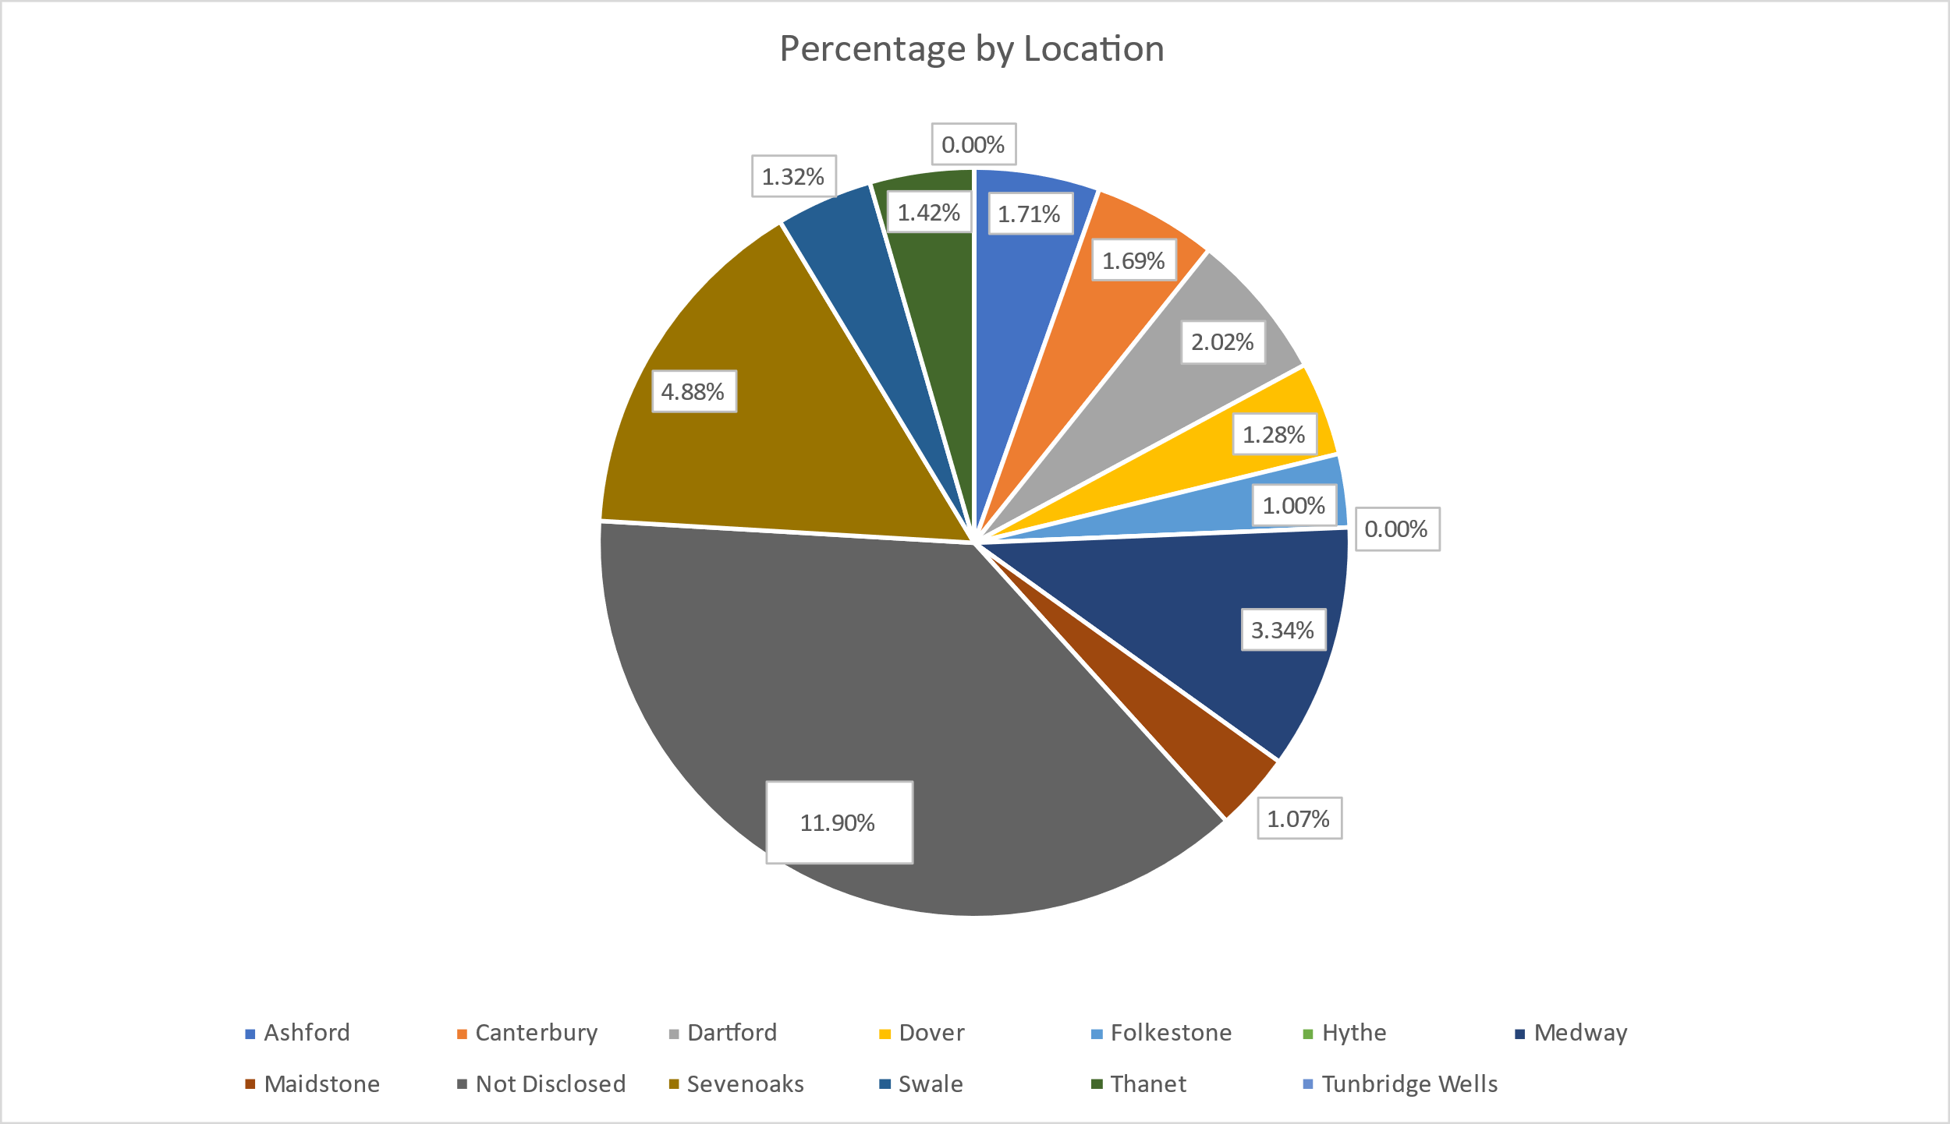

Concerns raised by Job Group

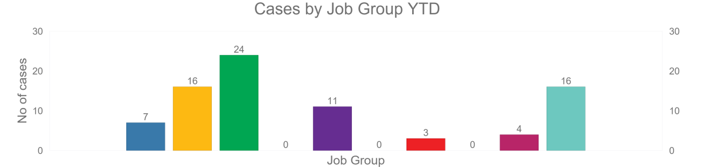

Why do staff use The Guardian Service?
The Guardian monitors why staff use the service. This data allows us to give feed back to the Trust. Staff contact the Guardian service usually when they feel that they have not been listened to, lack confidence, or are fearful about the potential consequences if they speak up internally. In many cases staff members contact the Guardian Service because they feel psychologically safer speaking up to an independent party.

Detriment
There were no reported incidents of detriment suffered because of speaking up.

Action taken to improve the Freedom to Speak Up Culture
Implementation of the Guardian Service within KMPT has offered a confidential and anonymous route for employees to Speak Up. This was in response to the staff survey in 2021 where staff shared, they didn’t always feel psychologically safe when raising concerns internally. Since the implementation of the service the Guardian has been increasing visibility across the trust to raise awareness of how to raise concerns and the importance of speaking up.

Visits and Briefings
The Guardian carries out a mix of Promotional Site Visits, Briefings and Communication Meetings within the trust. Promotional site visits raise awareness of the service, offer engagement with staff within the workplace and share information on positive speaking up culture. These also offer insight into the working environment and any challenges that employees may be facing. Briefings are carried out at both managers and corporate inductions and within team meetings so that staff have an awareness of how to raise concerns and the importance of speaking up. Communication meetings are held with key people within the trust to ensure collaborative working and sharing of themes. This includes but is not limited to the Executive Lead, CEO and NED for FTSU.

During this period the following visits and briefings have taken place:
Promo | 37
Comms | 21
Briefing | 57
Total | 115

Contacts
When handling cases the Guardian may have many contacts with individuals to support resolving any FTSU matters raised. These may include face to face, telephone, or email contacts. Where possible the Guardian will always offer a face-to-face meeting.
During this period the following number of contacts were made in relation to the 81 FTSU matters raised with the service:
Email | 599
Telephone | 318
Face to Face | 61
Total | 1577

- Monthly meetings with the Chief People Officer to talk through the monthly activity reports which includes themes and outcome of cases. No individual can be identified by the discussion of themes therefore maintaining staff confidentiality where requested.
- Quarterly meetings held with CEO and NED for FTSU to discuss emerging themes and learning points.
- Quarterly one to one meetings are held with HR Business Partners to support understanding of any themes or data regarding each care group.
- The Guardians assists managers in identifying issues within a specific team by offering a one-to-one session with each staff member so that they could confidentially and anonymously raise their concerns.
- The Guardian Service produces a summary of themes and observations for management so that issues can be targeted and resolved.
- All corporate and managers inductions include a briefing from the Guardian Service.
- Biannual reports to be presented to the board to share data and themes on Speaking Up.
- The Trust has implemented NHSE Freedom to Speak Up training as mandatory to all staff within the trust.
- The Trust is currently implementing the new national standard Freedom to Speak Up policy within the trust to offer more accessible language on speaking up and the procedures for doing so.
- A communications plan was implemented with information relating to The Guardian Service displayed on all Trust computer screen savers, intranet, Vlog and posters/flyers distributed across all sites.
- A new role profile for Freedom to Speak Up Champions has been created in line with NGO guidance and a recruitment drive to develop a network of champions to support development of a positive speaking up culture is in place.

Learning and Improvements
The Guardian routinely meets every week with other FTSU Guardians from across England, Scotland, and Wales. This contributes to continued learning of how to best address complex concerns and aids the sharing of best practice. It also represents an opportunity for Trusts to compare policy/procedure with other Trusts to help to identify and share best practice.
FTSU Guardians attend the meetings and events organized by the National Guardian Office (NGO). This, in addition to the NGO Bulletins, enables Guardians to keep up to date with developments in the field which supports the effective handling of concerns.
The Guardian Service has clients across several NHS Trusts and are therefore able to compare and contrast best practice approaches in respect to policy, service implementation and organisational response.
All FTSU Guardians have a minimum of two sessions per annum with a Psychotherapist and can have additional sessions when/if required.
All FTSU Guardians are trained Mental Health First Aiders, thereby providing an enhanced service to members of staff contacting the Service.
All FTSU Guardians are provided with resilience training.

Comments & Recommendations
Communication
- Staff feel more supported if they are informed of plans to resolve situations.
- Staff feel valued and heard if they receive feedback.
- This can be improved by wider information sharing and active listening.
Discrimination and equality
- Although concerns raised in this theme were low, there is conjecture that there are areas where racist behaviour is being displayed.
- It is a recommendation that there is robust training for all staff and a clear message from the Trust that any form of discrimination and inequality is not acceptable.
- It is recommended there is EDI training with sessions such as unconscious bias for all staff, to help create a better understanding of working in a diverse culture
- Managers should all be provided with Discrimination & Equality training refreshers, so that they are familiar with policy, legislative requirements, and best practice.
- All staff should be encouraged to display inclusive behaviours.
Management Training
- Managers should receive training or refresher training in speaking up, listening up and following up.
- Feeling heard can help to prevent a feeling of futility when speaking up, but managers also need to be reminded of the importance of confidentiality.
- Managers should be working with HR to ensure staff members fully understand and feel supported in the process of matters, such as redeployment and returning to work after long time sick.
- The Guardian Service and the NGO have developed respective toolkits (Freedom to Speak Up: A guide for leaders in the NHS and organisations delivering NHS services toolkit and The Power of Speaking Up) to support executive teams of NHS trusts to examine their practice and foster open cultures and behaviours that are responsive to feedback from workers.
- The executive lead for (FTSU) will use the guidance available from the toolkits and NGO self-review tool to help the board reflect on its current position and the improvement needed to meet the expectations of NHS Improvement and the National Guardian’s Office. This is on going and almost completed
- Please note I have attached the Guardian service tool kits at the end of this paper.

There were recommendations in the six-month report these are ongoing, and the recommendations carried forward have been actioned.

Neurodiversity Awareness
- It was a recommendation that considerations be taken to look at how to develop and implement plans to support both individuals and managers, for staff members that could be neurodivergent.
- Since the six-month report there is now a neurodiversity transformation team. They have created a support project, utilising people with lived experience. It is recommended that these projects continue to grow and can reach all staff.
Investigations and Formal Processes
- Within the cases for this period there was number of individuals who shared poor experiences whilst undergoing a formal process or investigation. This feedback related to timeframes being longer than expected; a lack of communication from the Trust during this period and/or the investigation itself not being to an expected standard. The trust has shared considerations for a team to be in place dedicated to carrying out investigations and it would be a recommendation that this is followed up and implemented to mitigate further negative experiences. This has now been agreed and recruitment is to commence.

Staff Feedback
‘Thank you for listening to me I now feel I can speak to my line manager and tell them how I feel ‘
‘Speaking with you has given me some clarity to think about my situation and how I resolve it’
‘I feel so supported that you escalated my concern, and I had such a quick response’

https://www.gov.uk/government/publications/report-of-the-mid-staffordshire-nhs-foundation-trust-public-inquiry

